Question | Suggested Solution
1(a) | - Dissolve the basic iron(III) oxide in dilute HCl(aq)  Fe₂O₃(s) + 6HCl → 2FeCl₃(aq) + 3H₂O(l)  - Add dilute NaOH(aq) in excess to solution formed in (i). Reddish brown precipitate of Fe(OH)₃ will be formed.  Fe³⁺(aq) + 3OH(aq) → Fe(OH)₃(s)  OR  Add aqueous potassium thiocyanate to solution formed in (i). A blood red colouration will be seen as a result of the formation of complex.  Fe³⁺(aq) + SCN(aq) → [Fe(SCN)]²⁺(aq)
(b) | Preliminary Considerations  ZnCO₃(s) + 2HCl(aq) → ZnCl₂ (aq) + CO₂ (g) + H₂O (l)  Zn(OH)₂ (s) + 2HCl(aq) → ZnCl₂ (aq) + H₂O (l)  To determine mass of ZnCO₃(s) present, react ZnCO₃ with excess acid and collect volume of CO₂ (g) evolved by using a 100 cm³ syringe. Zn(OH)₂ reacts with acid but does not give gas.  Assume volume of CO₂ (g) collected be 80 cm³.  Amt of CO₂ = 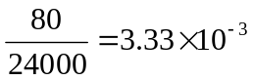mol  Amt of ZnCO₃ to give 80 cm³ of CO₂ = 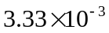 mol  Mass of ZnCO₃ required = () (Mr = 125.4) = 0.418g  Volume of calamine lotion required for reaction = 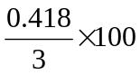  = 13.93 cm³ ≈ 14 cm³  (suitable volume 10-15cm³)  100 cm³ of calamine lotion contains 2-3 g each of ZnCO₃ and Zn(OH)₂.  14 cm³ of calamine lotion contains 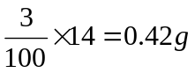 each of ZnCO₃ and Zn(OH)₂.  Amt of Zn(OH)₂ = 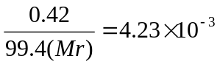mol  Amt of HCl to react with Zn(OH)₂ = 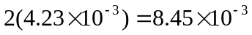mol  Total volume of HCl required for reaction with calamine lotion  = V_{HCl} for reacting with ZnCO₃ + V_{HCl} for reacting with Zn(OH)₂  = 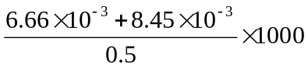  =30.1 cm³  Use excess acid to ensure reaction goes to completion.  Use 40 cm³ of 0.5 mol dm⁻³ HCl.  Procedure  - Using a measuring cylinder, measure 40 cm³ of 0.5 mol dm⁻³ HCl into a thistle funnel.  - Using a different measuring cylinder, measure 14 cm³ of calamine lotion into a clean conical flask. Make sure the calamine solution is well-shaken to obtain a homogeneous solution before measurement.  - Set up the apparatus as shown. 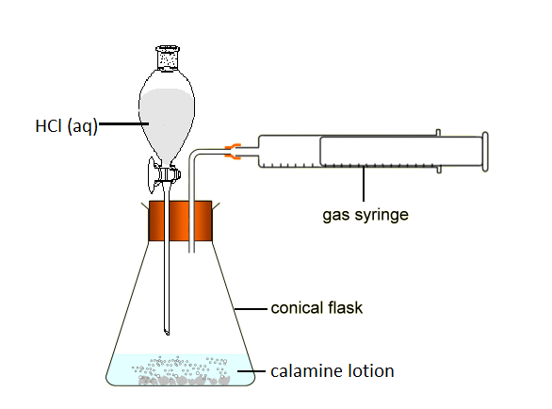  - Turn on tap to introduce HCl acid to the calamine and turn off the tap immediately.  - Collect CO₂ (g) evolved using a 100 cm³ syringe with a frictionless piston.  - Record the volume of CO₂ gas collected after the fizzing stops/ piston of the sypringe stops moving/volume stops increasing. Let the volume collected be Vcm³.  Sample calculations  ZnCO₃(s) + 2HCl(aq) → ZnCl₂ (aq) + CO₂ (g) + H₂O (l)  Volume of CO₂ (g) collected be V cm³.  Amt of CO₂ = 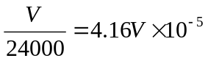mol  Amt of ZnCO₃ in 14cm³ of calamine lotion = 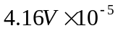 mol  Mass of ZnCO₃ in 100cm³ of calamine lotion =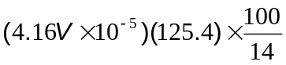g =m g
(c) | - Filter 100cm³ of well-shaken calamine lotion and collect the solid residue on a pre-weighed clean, dry filter paper.  - Wash the residue with a small amount of distilled water.  - Dry the solid overnight/ in the oven with low temperature/dessicator until a constant mass is obtained.  - Weigh the dry solid and filter paper  - Determine the mass of the dry solid.  Sample calculations  Mass of dry residue in 100cm³ of calamine lotion = C g  % by mass of ZnCO₃ in solid material of calamine lotion = 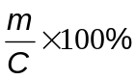
  Mass of dry residue + filter paper /g | A
  Mass of dry filter paper /g | B
  Mass of dry residue only /g | C= A-B
2 (a) | Cr [Ar] ↑ ↑ ↑ ↑ ↑ ↑  Cr in [Cr(NH₃)₆]³⁺ [Ar] ↑ ↑ ↑
(b) (i) | Chromium had more number of protons which contribute to a greater actual nuclear charge.  D-electrons are poor screeners and thus the shielding effect of chromium and potassium are similar.  Therefore, chromium will have a higher effective nuclear charge which make the removal of the electron harder and it will require a higher first IE.
(b) (ii) | Chromium contribute more valence electron per atom (3d + 4s electrons) as compared to potassium which contribute only 4s electrons.  Cr ion has higher charge density due to its high charge and smaller cationic radius  Therefore, stronger electrostatic forces of attraction between Cr ions and the sea of electrons.
(c) (i) | Cr₂O₃ + 2Al → Al₂O₃ + 2Cr
(c) (ii) | 74.4 tons
(d) (i) | Eº_{cell} = +0.65V  Orange solution turns green with effervescence
(d) (ii) | Eº_{cell} = +1.37V  Grey green solution turns yellow
3 (a) | During compression, intermolecular forces of attraction / bonds are formed between N₂O₃ molecules and bond formation is exothermic.  The kinetic energy possessed by the particles at room temperature is insufficient to break the strong intermolecular forces of attraction, thus, the particles become more orderly arranged and closer to one another, forming a liquid.
(b) (i) | P = 924 kPa
(b) (ii) | In reality, there is presence of attractive forces between the gaseous molecules, resulting in a lower pressure exerted on the wall of the vessel.  OR  In reality, the volume occupied by the gaseous molecules cannot be considered to be negligible as compared to the size of the vessel.
(c) | Fraction of molecules  Molecular speed  NO  N₂O₃  NO has smaller molecular mass than N₂O₃, is lighter and thus has higher average molecular speed than N₂O₃.
4 (a) | Graph II.  Since Sr(NO₃)₂(s) → SrO(s) + 2NO₂(g) + ½ O₂(g)  ⇒Δn increases ⇒ΔS is positive  ∴ graph of ΔG against T should give a straight line with a negative gradient as  ΔG = ΔH - TΔS (Gibbs eqn)
(b) | (i) ΔH = + 600 kJ mol ⁻¹  (ii)Decomposition temp = 672 K
(c) | Decomposition temp of magnesium nitrate is lower than that of strontium nitrate.  Both magnesium and strontium ions have the same charge of +2.  Size of Mg²⁺ is smaller than Sr²⁺  ⇒ charge/size ratio of Mg²⁺ is larger than Sr²⁺  ⇒ Mg²⁺ is a better polarizer than Sr²⁺  ⇒ electron cloud of nitrate in magnesium nitrate will be distorted to a larger extent than that of strontium nitrate making the breaking of N-O bond easier  ⇒decomposition temp of magnesium nitrate is lower than that of strontium nitrate.
(d) | Solids obtained on heating strontium nitrate and magnesium nitrate are strontium oxide and magnesium oxides respectively.  SrO dissolves readily in water forming a colourless alkaline solution of Sr(OH)₂.  MgO is insoluble in water.
5 (a) (i) | Electrophilic Addition  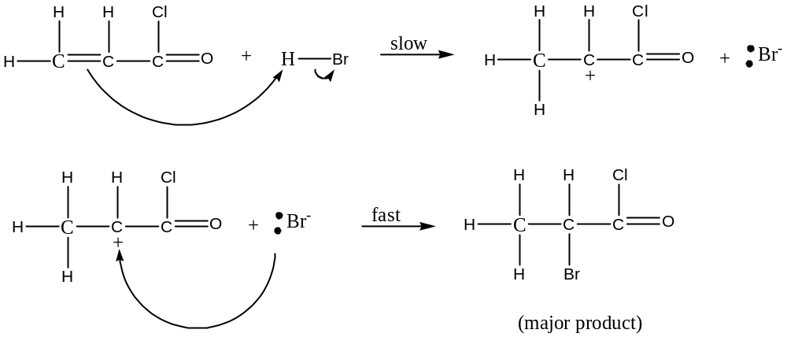  δ+  δ-
5 (a) (ii) | 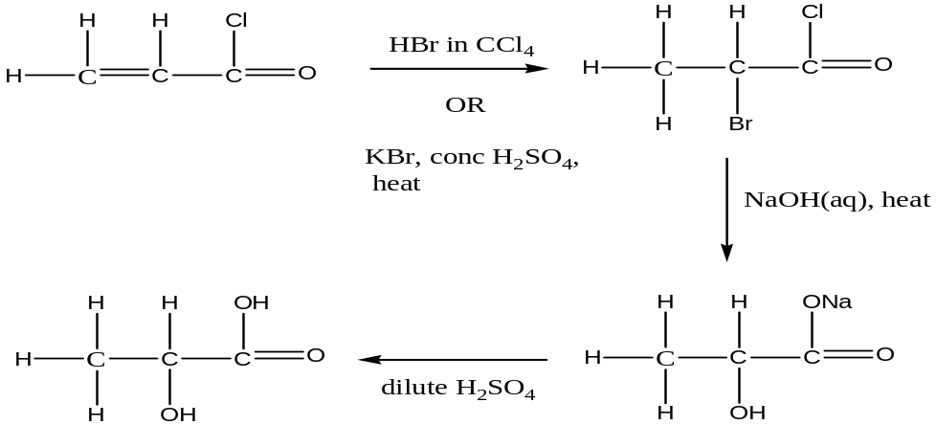  OR  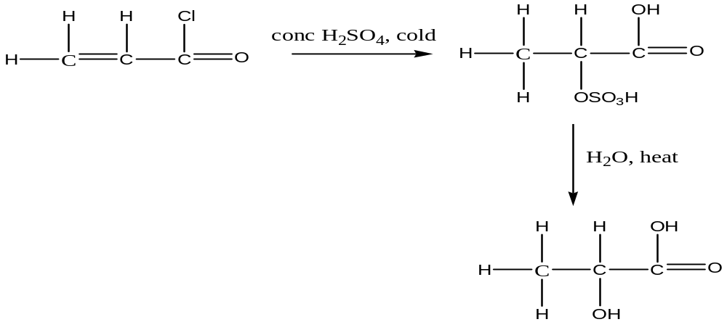  OR  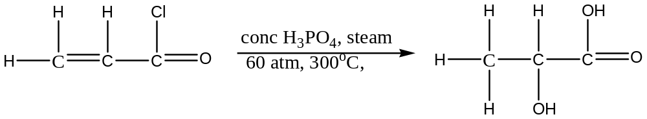
(b)(i) | KMnO₄, dilute H₂SO₄, heat  OR  K₂Cr₂O₇, dilute H₂SO₄, heat
(b) (ii) | Compound P Compound Q  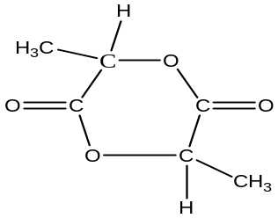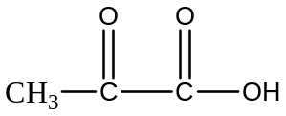  Compound R Compound S  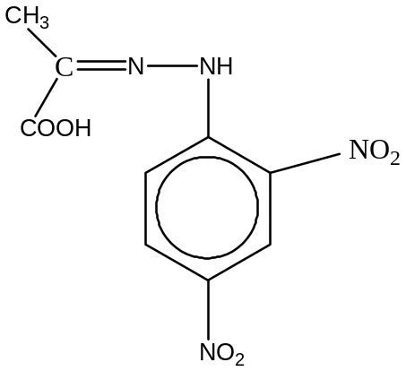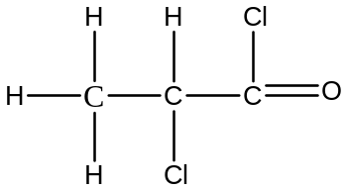  Compound T Compound U Compound V  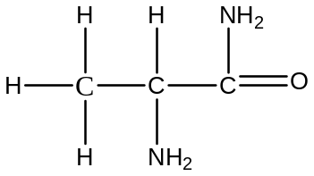 CHI₃ 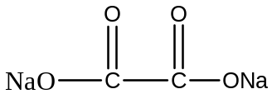
6 (a) | On going across Period 3, the hydroxides go from basic to acidic. This systematic variation is the result of  - the trend in the electronegativity of the elements, which leads to  - the difference in the bonding between the elements and the hydroxide.  Explanation:  - Going across Period 3, there is an increase in the effective nuclear charge of the elements, resulting in the increase in their electronegative values.  - This means that the difference in electronegativity between the elements and the hydroxide becomes smaller on going across the Period 3 hydroxides, resulting in the bonding between them changing from ionic to covalent.  - Ionic oxides/hydroxides are basic because of the presence of OH ions, and the covalent oxides/hydroxides are acidic due to the interactions of the partially positive elements with water, releasing H⁺ ion.
(b) | Aqueous aluminium nitrate has Al³⁺(aq) ions. These small and highly charged ions can polarize water molecules and undergo cation hydrolysis:  [Al(H₂O)₆]³⁺ + H₂O 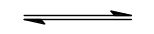 [Al(H₂O)₅(OH)]²⁺ + H₃O⁺  The H₃O⁺ ions produced in this hydrolysis decompose Na₂CO₃ to give CO₂ gas and this acid-carbonate reaction causes the equilibrium above to go to completion.  [Al(H₂O)₅(OH)]²⁺ undergoes further hydrolyses as follows until Al(OH)₃(s) results.  [Al(H₂O)₅(OH)]²⁺ + H₂O [Al(H₂O)₄(OH)₂]⁺ + H₃O⁺  [Al(H₂O)₄(OH)₂]⁺ + H₂O [Al(H₂O)₃(OH)₃] + H₃O⁺
(c) | 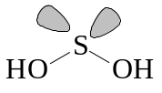 has two lone pairs of electrons around S, which force the  HOSOH bond angle to be much smaller than the tetrahedral angle. This result in the two O atoms brought very close together. Both of these O atoms carry considerable partial negative charge and each also possesses two lone pairs of electrons. The very strong repulsion between them makes the molecule highly unstable. Thus S(OH)₂ is unable to exist.
(d) | Cl(OH)
7 (a) (i) | At the alkaline pH of 10.76, the dissociation of the amino group of the side chain was suppressed. Hence, arginine exists as zwitterions at the pI value of 10.76.  ~NH₂ + H₂O ~NH₃⁺ + OH⁻
(a) (ii) | 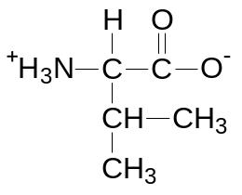
(b) (i) | Beta pleated sheet  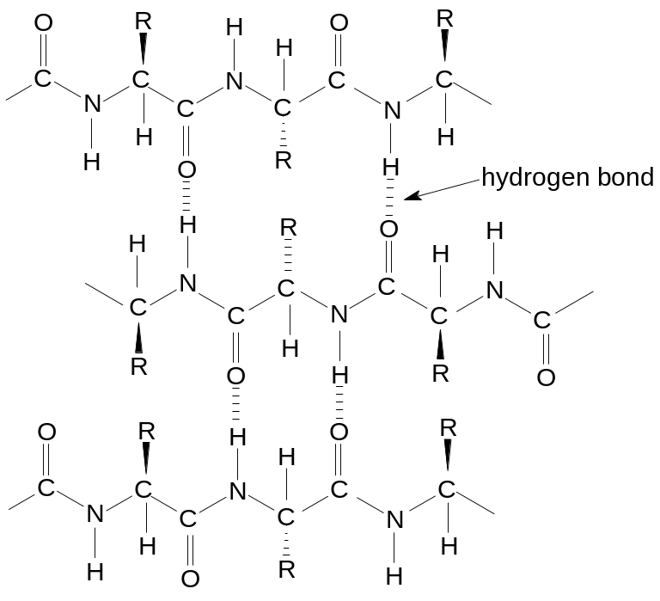
(b) (ii) | - Disulfide bridge: Cys and Cys  - Hydrogen bond : (1) Arg and Tyr  (2) Arg and Arg  (3) Tyr and Tyr  - Hydrophobic interaction: Val and Val
(c) | ( + )  (  –  )  Cathode  Original position of the 3 amino acids  Gel strip at pH = 6  Anode  Cys  Arg  Val  At pH of 6:  As pI of Arg is above pH 6 (acid medium), Arg is protonated to form a positively charged cation and migrates towards cathode.  As pI of Cys is below pH 6 (alkaline medium) Cys is deprotonated in alkaline medium to form a negatively charged anion and migrates towards anode.  As pI of Val is close to pH 6, Valine exists mostly in the form of zwitterions and remains close to the original center position.  Since M_{r} of Cys is smaller than Arg, Cys migrates faster Arg.

